LONGFORD COUNTY COUNCIL

BYE-LAWS FOR THE REGULATION AND MANAGEMENT OF CEMETRIES

IN COUNTY LONGFORD 2011

Application for Permission to Erect a Memorial Headstone/Other Structure or Amendment of Monument (Records) in a County Council Burial Ground

Company or person with responsibility for erecting the Monument or modifying the Record (e.g. Sculptor)

Name of Headstone Mason/Contractor/Funeral Undertaker/Sculptor:

Address: Tel. No. :

Name of Applicant: Tel. No. :
(Person with responsibility for purchasing the work)

Date of Purchase of “Right of Burial” & receipt no.:

Name of deceased:

Burial Ground: Plot No. Section:

Inscription:

Please sign below
State here the dimensions* and type of Monument that will be projecting above the level of the adjoining ground:
A brief sketch of the proposed monument should be attached to application.
NOTE:-

The restrictions on the maximum size of memorial permitted, i.e., “the height of any headstone that is erected on a place of burial shall not exceed 1.2 meters above the ordinary level of the surrounding ground. An exception in this regard will be allowed where it is proposed to erect a Celtic Cross. Where a Celtic Cross is to be erected it shall not exceed 2.5 metres above the ordinary level of the surrounding ground.”

“Lawn Cemetery” shall mean a Cemetery or part of a Cemetery in which the installation of kerbs or surrounds is not permitted, planting of shrubs on grave spaces shall not be permitted and where burial plots are maintained as grassed areas.
- Longford County Council is not a party to any works associated with excavations, erection and maintenance of headstones, memorials and kerbs and/or any contract associated with these works. Accordingly, Health and Safety Construction Regulations requirements pertain to the parties arranging for or carrying out the works and this does not include the local authority.
I have read and hereby agree to the terms of the Bye-Laws for the Regulation and Management of Cemeteries in County Longford 2011.

Signed: __________________________________ Date: _________________
(Applicant)

Signed: __________________________________ Date: _________________
(Headstone Mason/Contractor/Funeral Undertaker)
NOTES
- *Maximum Size of Memorial Permitted
The height of any headstone that is erected on a place of burial shall not exceed 1.2 meters above the ordinary level of the surrounding ground. An exception in this regard will be allowed where it is proposed to erect a Celtic Cross. Where a Celtic Cross is to be erected it shall not exceed 2.5 metres above the ordinary level of the surrounding ground.
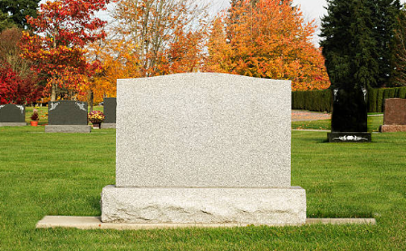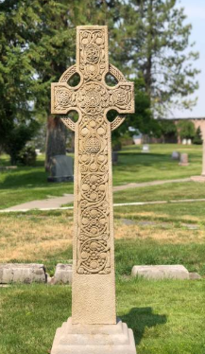
Celtic Cross not to exceed 2.5m above surrounding ground level.
Headstone not to exceed 1.2m above surrounding ground level.

- A copy of the Bye-Laws for the Regulation and Management of Cemeteries in County Longford 2011 are enclosed, and must be read prior to signing your application.

- Permission for erection of a headstone will not be granted until the grave price is paid in full to Longford County Council (please attach copy of receipt of payment).

- Work cannot commence prior to approval from Longford County Council. Please allow a minimum of 2 weeks from date of lodgement of application.

- Completed Application forms must be submitted for approval to:-
burials@longfordcoco.ie
The Environment Section,
Longford County Council,
Great Water Street, Longford.

- Once approval has been granted, the Cemetery Caretaker must be contacted to make arrangements to gain access to the Cemetery and agree a commencement date. The Letter of Approval must be presented to the Caretaker.

- No works are to be conducted outside of working hours of 10am to 4pm Monday – Friday

- **Lawn Cemetery
Aughafin Cemetery has an element of a Lawn Cemetery. “Lawn Cemetery” shall mean a Cemetery or part of a Cemetery in which the installation of kerbs or surrounds is not permitted and where burial plots are maintained as grassed areas.

The planting of shrubs on grave spaces in Lawn Cemeteries shall not be permitted and Longford Co. Co. reserve the right to remove any such items without notice.

The placing of flowers and wreaths on grave spaces in Lawn Cemeteries shall be permitted.

